Korak 2 — EMQX → CrateDB integracija
Sada ćemo napraviti:
- EMQX MQTT broker
- Rule Engine
- automatski zapis MQTT poruka u CrateDB
- realtime ingest za 1000 trafostanica
Koristit ćemo:
- EMQX
- CrateDB

Arhitektura
Locust
|
MQTT
|
v
EMQX
|
Rule Engine
|
PostgreSQL Wire Protocol
|
v
CrateDB

1. Docker Compose update
Dodaj EMQX i CrateDB.

docker-compose.yml
version: '3.9'  services:  cratedb:  image: crate:latest  container_name: cratedb  ports:  - "4200:4200"  - "5432:5432"  environment:  CRATE_HEAP_SIZE: 2g  command: >  crate  -Ccluster.name=trafostanice  -Cnode.name=node1  -Cauth.host_based.enabled=false  emqx:  image: emqx/emqx:latest  container_name: emqx  ports:  - "1883:1883"  - "18083:18083"  depends_on:  - cratedb | 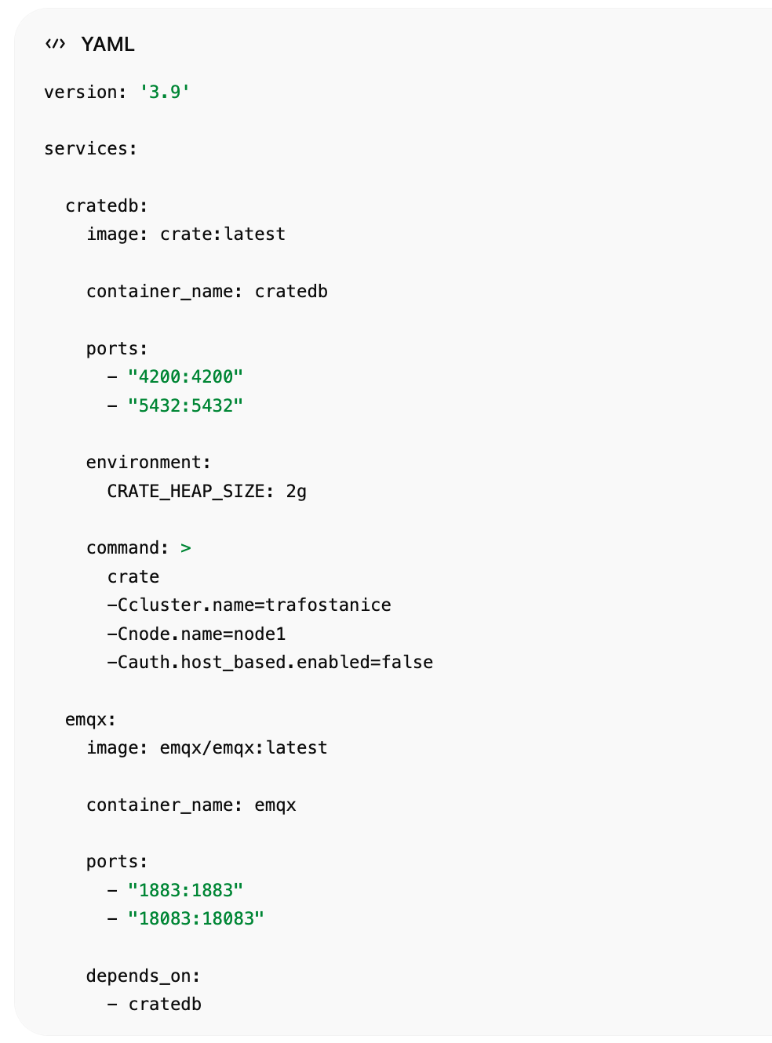

Pokreni stack
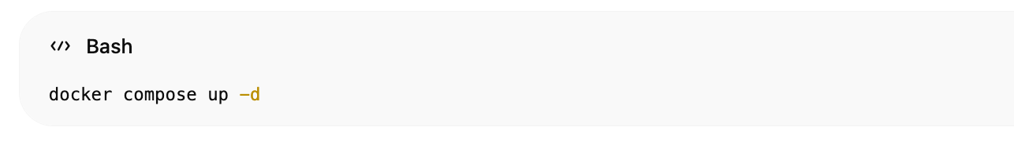docker compose up -d

2. Provjera servisa

CrateDB Admin
http://localhost:4200

EMQX Dashboard
http://localhost:18083
Login:
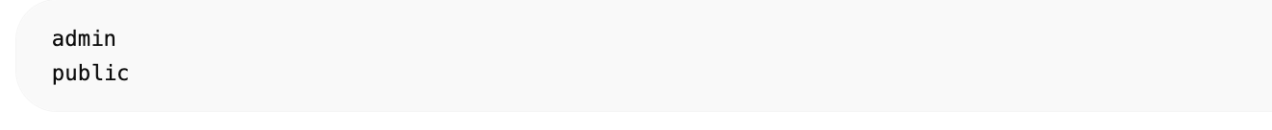admin
public

3. Kreiranje CrateDB tablice
Spoji se:
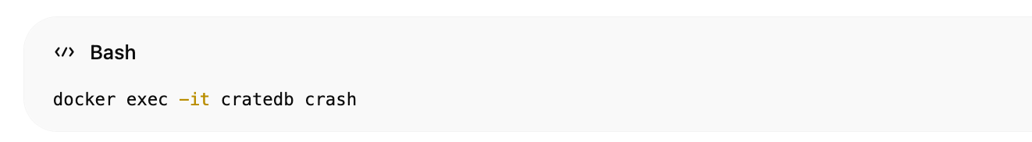docker exec -it cratedb crash

Kreiraj tablicu
CREATE TABLE trafostanice_sensors (  timestamp TIMESTAMP,  station_id TEXT,  station_name TEXT,  location GEO_POINT,  electrical OBJECT(DYNAMIC) AS (  voltage_kv DOUBLE,  current_a DOUBLE,  frequency_hz DOUBLE,  active_power_kw DOUBLE,  reactive_power_kvar DOUBLE,  harmonics_thd DOUBLE  ),  thermal OBJECT(DYNAMIC) AS (  oil_temp_c DOUBLE,  winding_temp_c DOUBLE,  busbar_temp_c DOUBLE,  ambient_temp_c DOUBLE  ),  oil_gas OBJECT(DYNAMIC) AS (  oil_level_percent DOUBLE,  oil_pressure_bar DOUBLE,  humidity_ppm DOUBLE,  hydrogen_ppm DOUBLE,  methane_ppm DOUBLE,  acetylene_ppm DOUBLE  ),  alarms OBJECT(DYNAMIC) AS (  overload BOOLEAN,  overheating BOOLEAN  )  ); | 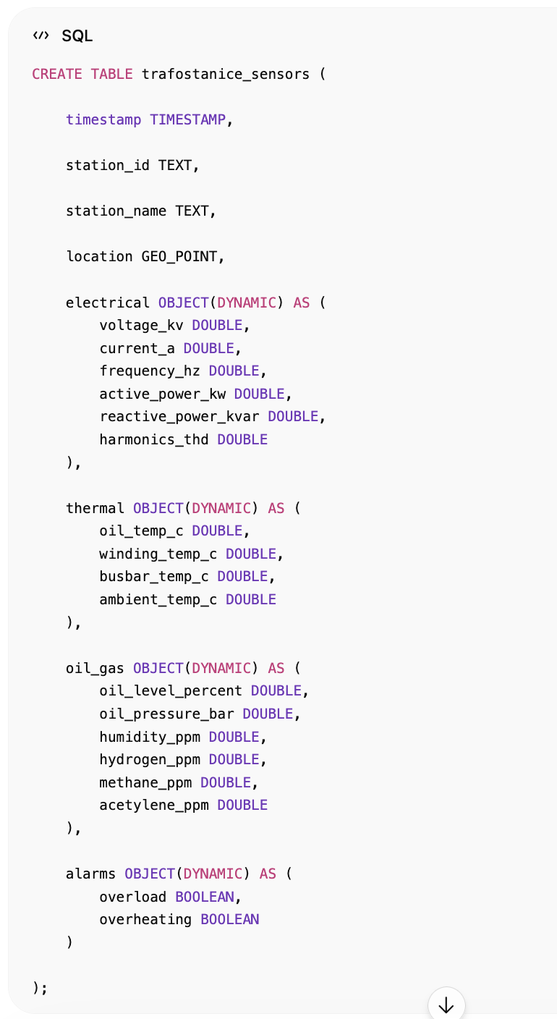

4. EMQX Rule Engine
Idi u:
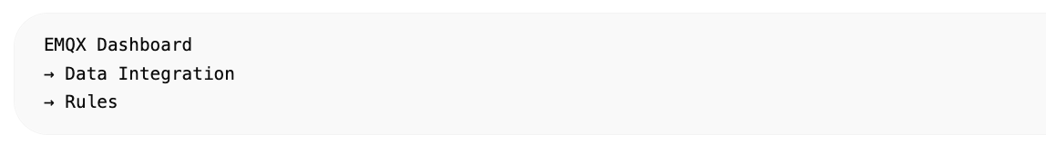EMQX Dashboard
→ Data Integration
→ Rules

Kreiraj Rule
Ime:
trafostanice_rule

SQL Rule
SELECT  payload.timestamp as timestamp,  payload.station_id as station_id,  payload.station_name as station_name,  payload.location as location,  payload.electrical as electrical,  payload.thermal as thermal,  payload.oil_gas as oil_gas,  payload.alarms as alarms  FROM  "trafostanice/+/sensors" | 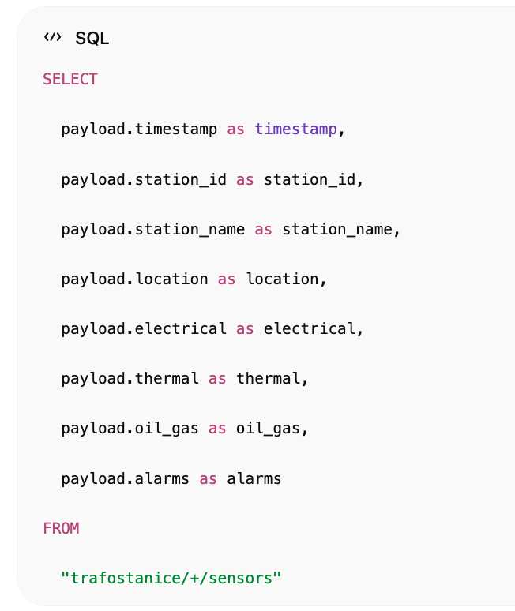

5. Dodaj PostgreSQL Connector
EMQX:
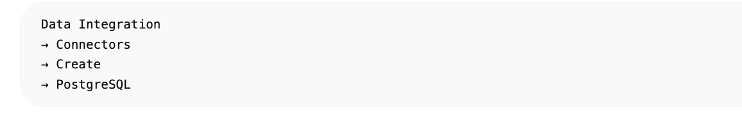Data Integration
→ Connectors
→ Create
→ PostgreSQL

PostgreSQL connector config

Name
cratedb_connector

Host
cratedb

Port
5432

Username
crate

Password
ostavi prazno

Database
doc

6. Dodaj Action
Rule:
trafostanice_rule
Dodaj:
PostgreSQL Action

SQL Insert
INSERT INTO trafostanice_sensors (  timestamp,  station_id,  station_name,  location,  electrical,  thermal,  oil_gas,  alarms  )  VALUES (  ${timestamp},  ${station_id},  ${station_name},  ${location},  ${electrical},  ${thermal},  ${oil_gas},  ${alarms}  ); | 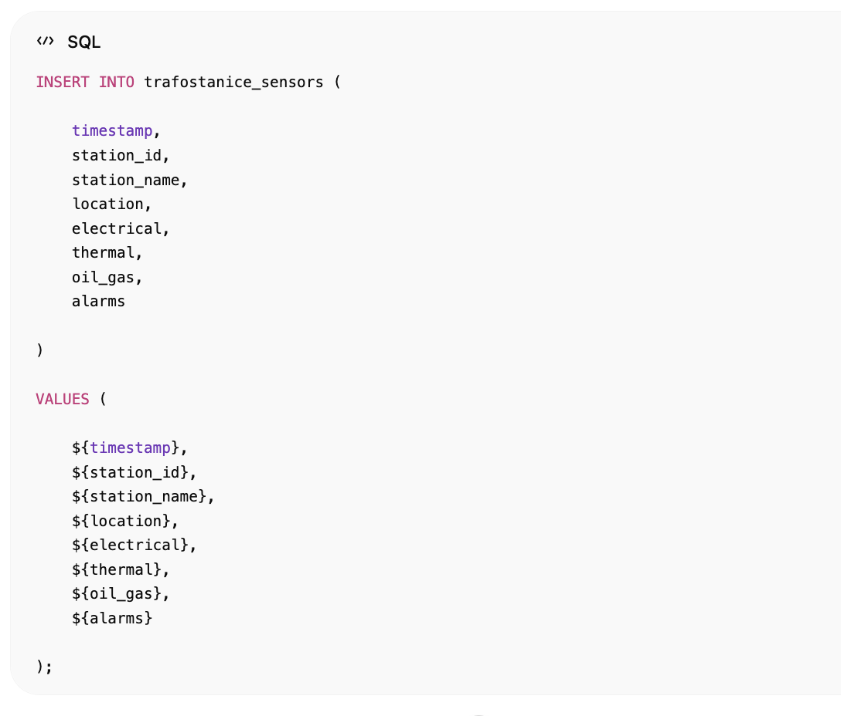

7. Test ingest
Pokreni Locust:
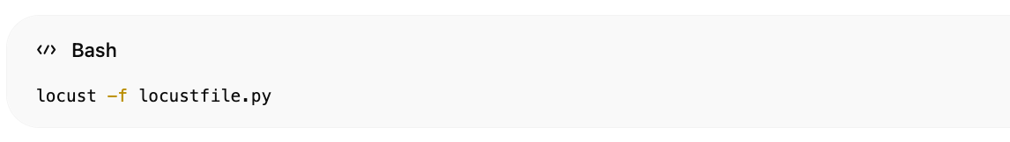
locust -f locustfile.py

Provjeri podatke u CrateDB
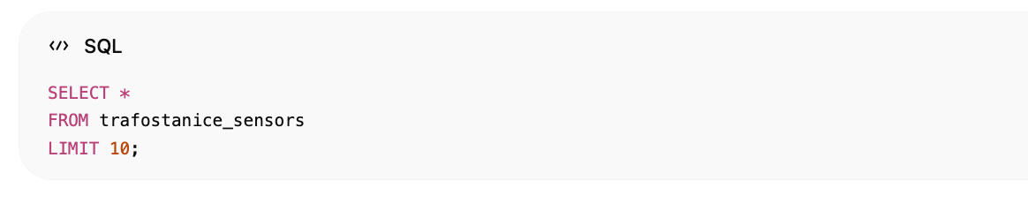SELECT *
FROM trafostanice_sensors
LIMIT 10;

Live query
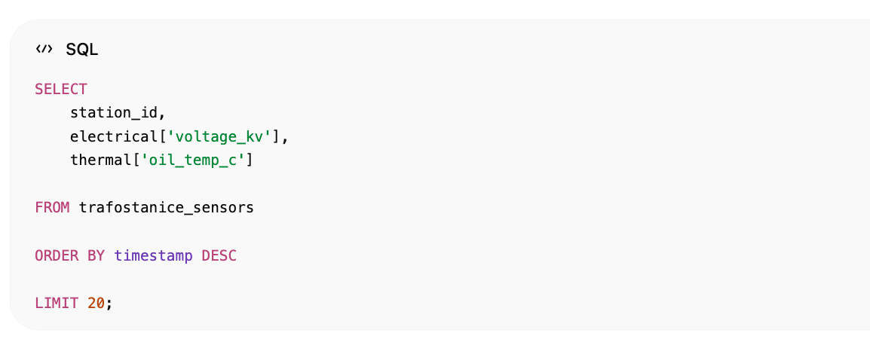
SELECT
station_id,
electrical['voltage_kv'],
thermal['oil_temp_c']
FROM trafostanice_sensors
ORDER BY timestamp DESC
LIMIT 20;

Alarm query

Overheating
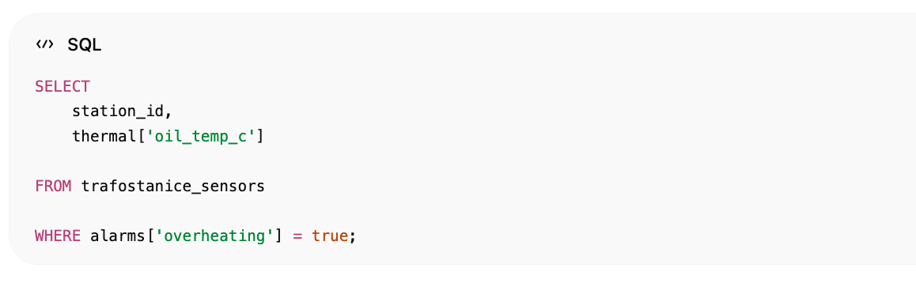SELECT
station_id,
thermal['oil_temp_c']
FROM trafostanice_sensors
WHERE alarms['overheating'] = true;

Geo query
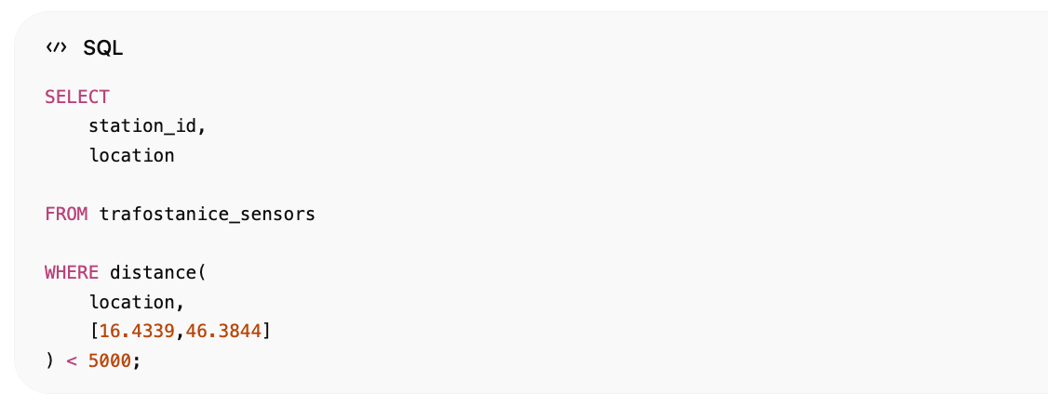
SELECT
station_id,
location
FROM trafostanice_sensors
WHERE distance(
location,
[16.4339,46.3844]
) < 5000;

Performance
Ovaj setup može bez problema:
- 1000 trafostanica
- 10k+ msg/sec
- realtime dashboard
- geo queries
- alarm analytics

Što sada imamo

Radi:
- MQTT ingest
- EMQX broker
- Rule Engine
- CrateDB storage
- realtime insert
- geolokacije
- alarmi
- vremenske serije

